**PROTOTYPE IMPLEMENTATION**

1. **Data Collection:**

Code In:

* Streaming.py
* Slistener.py

Tools/Packages Used:

* Twitter streaming API
* Tweepy
* python

Input:

“bjp”

Output:

<A set of Tweets>(In json format)

**EX:**

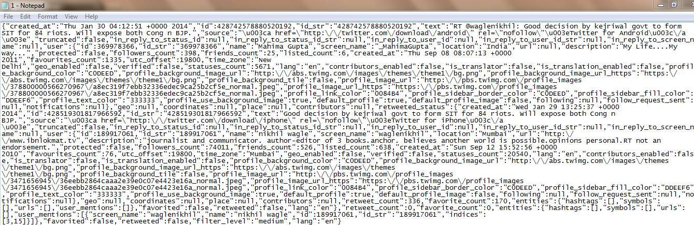

1. **PREPROCESSING:**

Codes in:

* procesLine.m
* getBi.m
* getTri.m
* getabbre.m

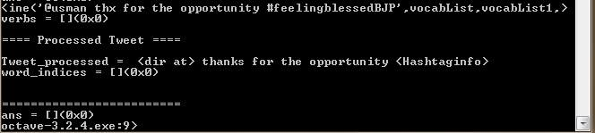

**3) Speech Act Recognition:**

Codes_in:

* Speech_act.m
* Logistics_regression:

predictOneVsAll.m

oneVsAll.m

costFunction.m

* Code used from Coursera

optimset.m

fmincg.m

* Packages:

svmtrain.o

svmpredict.o

* Input & Training files:

Input&training1.txt

Input&training11.txt

Input:

rt @waglenikhil: good decision by kejriwal govt to form sit for 84 riots. will expose both cong n bjp.

Output:

2-comment

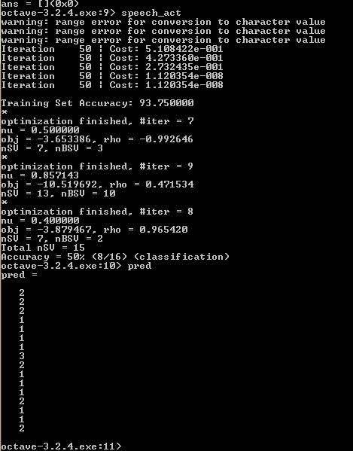

**4) Speech act guided Key word extraction**

Codes_in:

* Phrase_extract.p

Input:

sharad pawar, ever the hopeful, begins his pre election games of flirting with other parties. bjp remains unimpressed\n'

Output:

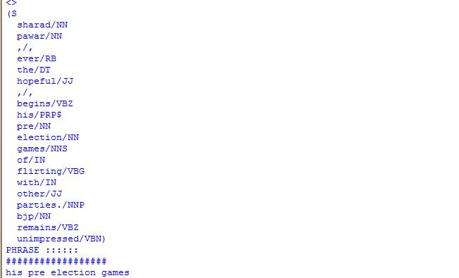

**5) Summarizer**

Codes_in:

* Hashtag_splitter.py

Hash Topic:

INPUT: **<**Tweets with hash tag**>**

**#**ihatebjp

OUTPUT: **<**correct split up of tweets**>**

i hate bjp

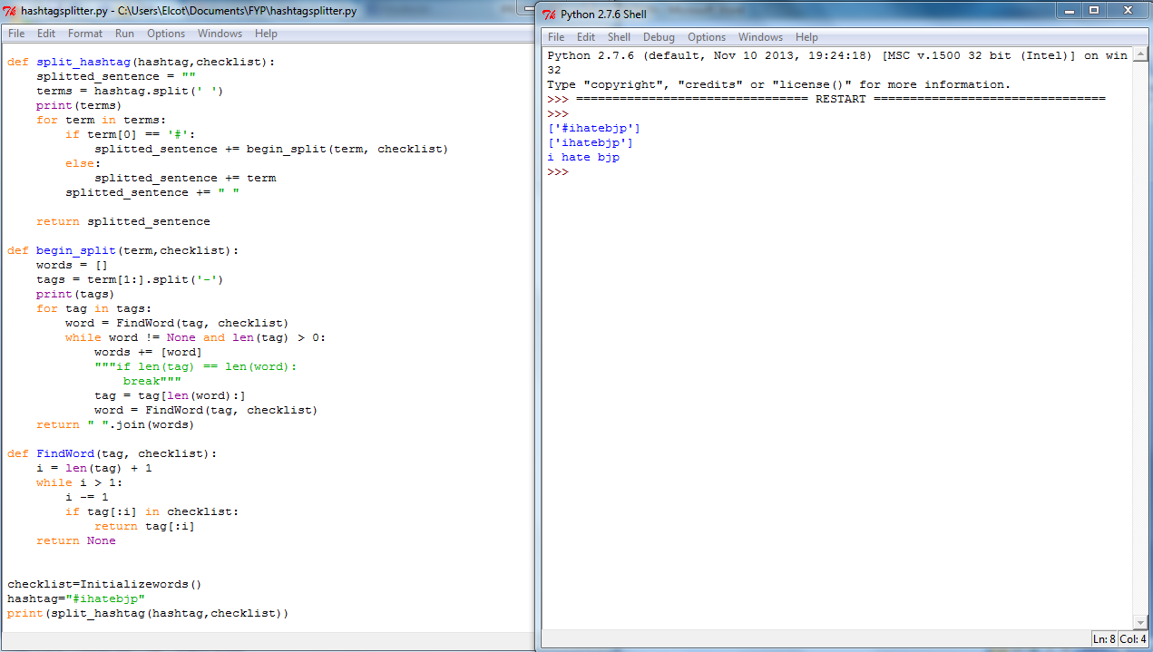

INPUT for remaining modules: **<**Timestamped tweets**>**

1) Comment<Timestamp 1>

issues between AAP & Congress Live-in. AAP & BJP can form a ideologically similar relationship for long term   
 2) Comment<Timestamp 2>

It will be fantastic if this can really be achieved by BJP in every constituency.   
 3) Statement<Timestamp 3>

BJP targets 272+ seats on own, plans Modi for PM fund (Video)

4) Comment<Timestamp 4>

congress back off now, prove that they r scared of AAP. safer with BJP in power.   
 5) Statement<Timestamp 5>

Party meetings in Delhi today   
 6) Comment<Timestamp 6>

Whole of India `Disillusioned'   
 7) Statement<Timestamp 7>

Party meetings in Delhi today

**Subtopic detection:**

* Stream-based:

**Split up into buckets of predefined time intervals is done.** Partial Code_in:

Set.py

OUTPUT: **<**Subtopics and tweets related to them**>**

Local peak:

Subtopic:PARTY MEETINGS (in timestamps 5&7)

* **Semantic-based:**

Tools :

* Gensim

Code:

* Dtm.py

Predefined Set of Topics:

* Riots
* BJP
* Selection

Input:

rt @waglenikhil: good decision by kejriwal govt to form sit for 84 riots. will expose both cong n bjp.

Output:

Shows a similarity to the predefined topics which helps in splitting tweets into subtopics

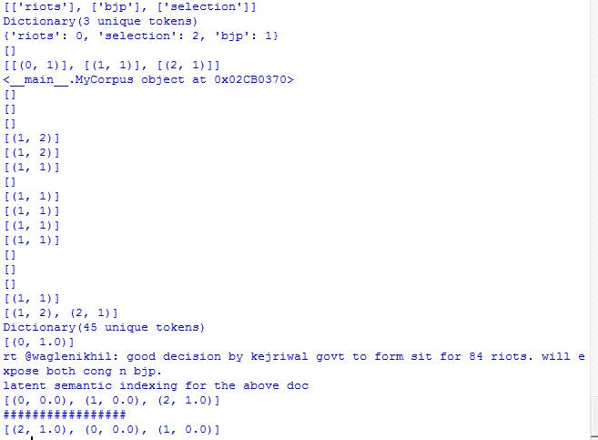

**TEMPLATES:**

Input: **<**keywords from tweets, classified Tweets**>**

Suggest, do your job

**OUTPUT: <**Templated sentences**>**

The suggestion is to do your job

**OUTPUT: <A summary of tweets>**

The general opinion among people is that there will always be issues between AAP and Congress, though BJP can form an ideologically similar relationship with AAP. It is of the general opinion that if congress back off now then it’ll prove they are afraid of AAP. BJP targets 272+ seats on own, plans Modi for PM fund BJP Party Meetings held in Delhi today